GROUP 6

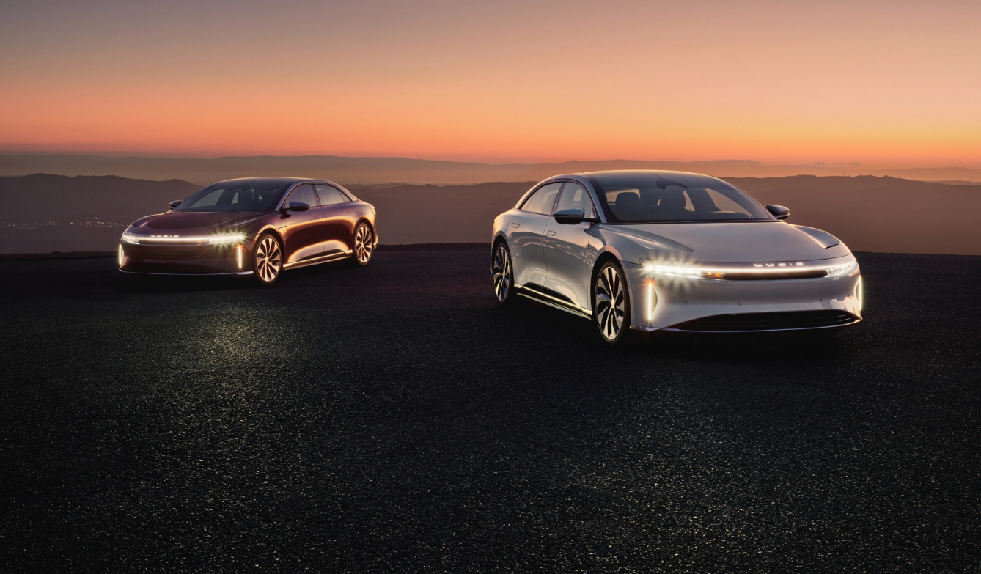

PROG8060- DEVELOPING QUALITY APPLICATION

PROJECT PROPOSAL

FOR

CAR DEALERSHIP BOT

Group Members

Vanmathi Subramanian - 8879682

Preethi Manjuvanda Ganesh - 8825486

Tuney Mathew - 8848045

Anshu Abraham - 8756283

1. **Project Background and Description**

This project is about a Car Dealer Bot (chatbot) which is exclusively for automotive dealers and customers who want to buy cars. The main purpose of this project is to generate leads and to enhance customer service where customers can interact with agents daily.

1. **Problem Statement**

The goal of this project is to increase customer engagement and make sure that the users can connect with agents 24/7 where they can get instant response without being physically present in the showroom. This chatbot is not just an efficient way to communicate with customers but it will also generate more sales/leads and increase bookings. This will enhance customer satisfaction and reduce incompetency and human errors.

1. **Project Scope**

In this project we will try to build a chatbot that can incorporate a common-sense database to provide simple but relevant responses while chatting. We need to successfully parse human input and find the most relevant keywords with some understanding of the context. This will address the key queries via this chatbot where repeated questions can be answered. This chatbot will only deal with new customers while existing customer tickets will not be answered and the chatbot will be in English version and not all languages are supported.

Overall, this project will have faster response to the customer, reduced hours over the phone calls and increases generation of leads.

1. **High Level Requirements**

The new system must include the following:

* Ability to be able to initiate a chat with the car dealership.
* Ability to be able to configure the automobile based on a question-and-answer model.
* Ability to be able to place an order or forward the automobile configuration details to the dealership.

1. **Materials and Tools Required**

The new system will be built with the help of below tools.

1. Front End Development Framework – HTML, CSS, Bootstrap, Javascript, JSON
2. Back End Development Framework – C#
3. Database If required – Microsoft SQL Server
4. IDE – Visual Studio Code, Visual Studio 2022 Community Edition
5. Unit / Integration / System Testing Framework – nUnit
6. Performance Testing Framework – Apache JMeter
7. Defect Tracking System – Bugzilla
8. **References Used**

Tars Technologies. Inc (2023)

<https://hellotars.com/chatbot-templates/automotive/ry5EOi/car-dealer-bot>